IMAT345: Computing Final Year Project – Final Submission

Procedural Content Generation for Mobile Games

Dominic Gibson
P13214758

Table of Contents
Abstract 3
1.0 – Introduction 3
2.0 – Project Design 3
2.1 – Analysis of Requirements 3
2.1.1 Procedural Content Generation (PCG) System Requirements 3
2.1.2 Game Requirements 3
2.2 – Design Considerations 3
2.2.1 PCG System 3
2.2.2 Demonstration Game 5
2.3 – Final Design 5
2.3.1 PCG System 5
2.3.2 Demonstration Game 5
2.3.3 Design Justification 5
2.4 – Implementation 5
3.0 – Conclusion 6
3.1 – Evaluation of Product 6
3.2 – Evaluation of Approach 6
3.3 – Evaluation of Tools 6
3.4 – Future work and Final Thoughts 6
Appendices 6
4.0 – Testing 6
5.0 – Technical Design 6
5.1 – Class Diagram 6
5.2 – Algorithms 7
6.0 – Ethical Review and Project Contract 7
7.0 – Project Management 7
7.1 – Project Plans 7
7.2 – Sprint Logs 7
7.3 – Progress Logs 7
8.0 – Bibliography 7
9.0 – Figures 8

Abstract

1.0 – Introduction

2.0 – Project Design

2.1 – Analysis of Requirements
The original proposal for the project was “The use of procedural methods to develop content for mobile games incorporating the player's context with a focus on Computational Intelligence (CI) techniques.” From this brief two major components were identified; a system that used CI techniques to procedurally produce game content and a mobile game demonstrating this system in use. The following sections break down the key requirements for these two components identified from the propose and research.

2.1.1 Procedural Content Generation (PCG) System Requirements
- Usability of content – The system produced what Togelius refers to as 'necessary' content.[4]
- Computational Intelligence – The system had to make use of suitable CI techniques such as evolutionary algorithms or neural networks. Similarly, as discussed in the research (section 2.3 of literature review) CI produces more varied, interesting and engaging content then more simplistic techniques.
- Online Generation – The use of the player's context in the PCG process ruled out the usage of offline techniques to pre-generate content during development. This also means the system must execute at run time of the game.
- Efficient performance – The system had to be able to execute at a reasonable performance on the restrictive hardware of mobile devices.
- Usability of framework – The overall design needed to be clearly defined and easily applied to other projects.

2.1.2 Game Requirements
- Demonstrate Level Generation – The sample game must effectively demonstrate use of the level generation system.

2.2 – Design Considerations

2.2.1 PCG System
The requirements for this project were relatively unrestrictive resulting in a number of open design choices such as the form and type of content to generate and the CI technique to use. The literature review highlighted the huge range of approaches to PCG and the type of game content produced.

The choice of what the system procedurally generated had a major impact on all other design decisions. A number of forms of game content were considered during the early stages of the project including levels, items and narrative.
Narrative generation was not pursued based on the findings of the literature review (Section 2.4). Though it shares a number of similar challenges to other forms of content generation it is significantly more complex to generate an engaging and coherent plotline and has yet to be successfully applied outside of experimental games. Another reason for why it was not chosen was the requirement that the PCG Framework be easily translated across projects. Game narratives are often genre specific and combined with increased complexity of generation meant that it was not feasible for the project.
Game items, specifically weapons, were also considered for the output of the system. While often tied to the mechanics of the game, the properties of weapons could sufficiently abstracted to enable a reusable generation system. Similarly, unlike game narratives, procedurally generated game items have be used in commercial games.[5][6] However, level generation was ultimately chosen due to the wider range of techniques previously used and the larger focus in both research and industry on level generation.
There is an overwhelming number of PCG techniques that can applied to level generation. For more detail the literature review provides a comprehensive overview of field. The Online and CI requirements narrowed the choice down to searched-based methods. Search-based PCG is a content generation methodology that searches for the optimal solution, in this context the game content. At every iteration a number of potential candidates are created and scored based on some assessment criteria to help guide the search until context of a sufficient quality is found.
Again, even within this subcategory there are a number of possible approaches that can broadly be broken up into interactive and direct evaluation based searches; both with their own advantages and draw backs.
Interactive evaluation requires an agent to assess the quality of the generated content though the research found it was not applicable for the project. Use of a software agent to simulate gameplay of the levels could produce high quality content but was not possible with the run time requirement. A selection of evaluation systems using either direct user assessment or player modelling where considered (literature review p.g. 13) and ultimately rejected. Direct user involvement is disruptive to gameplay and potentially requires the player to experience poor content until their assessment directs the search to suit them. Similarly, non-disruptive gathering of feedback through measuring the players actions (number jumps, deaths etc.) often leads to noisy or inaccurate data making any guidance to the search questionable at best.
Direct evaluation algorithmically assesses the quality of the produced content using a fitness function. This approach, implemented as a genetic algorithm(GA), has been successfully used to generate levels in several different genres including platformers, mazes and strategy games.[7-9] One of the key benefits of GAs is their ability to find multiple distinct solutions to a problem. In the context of level creation, a GA can produce a number of levels in a single run. The main drawback to the use of GAs is that the creation of a function that efficiently and accurately quantifies the quality of a game level is a non-trivial task (See Section 2.4). Similarly, the execution time of a GA can vary wildly on successive runs depending on the complexity of the fitness function and how far from optimal the initial population is. To mitigate this, the final design uses a combination of constructive and search-based generation techniques, described in detail in sections 2.3 and 2.4.
The final design consideration was how to include the player's context into the level generation process. One idea was to seed the random number generator using either the player's location or a touch screen gesture but both were discarded was there would no real noticeable change to the generated levels as the player's context changed. Instead, the player's location is used to look up the local weather so that the generated level reflects their surroundings.

2.2.2 Demonstration Game
The main design consideration for the sample game was what genre would be able to fully demonstrate the level generation system. Originally a simple grid locked turn based tactics game was planned however due to time constraints near the end of the project the design was scaled down to a more simplistic 'Legend of Zelda'-esque game. Both styles of game share tile based movement and top down camera views and thus can both demonstrate the systems ability to generate engaging and challenging levels. No change to the level generation system's code was required for this gameplay change showing that the approach can easily be reused.

2.3 – Final Design
The final design is a development framework that demonstrates the implementation and use of a novel approach to real time procedural content generation.

2.3.1 PCG System
Figure ?? shows the structure of the framework. The level generation process is separated into two main interfaces; LevelGenerator and PopulationGenerator.
The LevelGenerator implementation (Section 2.4.1) uses layered Perlin noise to procedurally generates the game level's base terrain features such as islands, rivers, mountain ranges etc. These features are returned in an implementation agnostic format as a heightmap.
The PopulationGenerator implementation(Section 2.4.2) then uses a genetic algorithm to generate the number and positions of game entities using the heightmap created by the LevelGenerator and the Constraints specified by the developer calling the system. The combined heightmap and entities represent a potential game level referred to as a MapCandidate. Once the generation process completes a list of MapCandidates is returned to the caller.
The Constraints object is a collection of properties that can be defined programmatically or read in from an XML file at run time. The available properties are defined below:
- mapWidth – The width of the level.
- mapHeight – The height of the level.
- objectivesEnabled – Specifies whether to add objective marks during the level generation
- length – The target maximum path length between the start position, end point and objectives.
- Difficulty – A value between 1-10 specifying the target challenge of the level.
- PopulationSize – The number of MapCandidates created each generation of the GA.
- MaxGenerations – The maximum number of generations the GA can run before returning.
The final component of the level generation process is the WeatherClient which, if available, retrieves the weather conditions at the player's latitude and longitude. The temperature and atmospheric conditions effect both the terrain generation and how the level is rendered in game. The rules for how the weather effects the level are as followed:
- Below zero temperature or snowing – snow tile set is used.
- Heavy rain or fog – The water level of the terrain is raised and the swamp tile set is used.
- Above 30 degrees – The water level of the terrain is lowered and the desert tile set is used.
Figures ?? - ?? show the use of this system.

2.3.2 Demonstration Game
The sample game is a relatively simple action-adventure game inspired by Game Boy Colour era titles.
The game is played from an Orthogonal viewpoint where the player controls a single character with four directional grid based movement.
The core gameplay revolves around fighting passed enemies to light beacons scattered across the level. Chests are also placed throughout the level and heal the player when opened.
Once the player has lit all the beacons the level is compete and the option to either play another level from the current pool or to generate a new selection of levels is presented to the player.
Figures ?? and ?? show the game's UI and controller design while Figure ?? shows the storyboard of player interaction with the game.

2.3.3 Design Justification
As touched on in the previous sections and discussed thoroughly in the literature review, the choice of PCG approach has a significant impact on the quality and performance of the system. A purely constructive approach, though fast, cannot easily account for high level design concepts, such as balance and player engagement, and do not meet the CI requirement. On the other hand, advanced CI techniques such as [9] are capable of producing content that satisfies design constraints but will not have online performance on mobile devices.
In an attempt to mitigate these issues, the final design uses the hybrid approach outlined above. The quick execution time and aesthetically pleasing output of Perlin noise frees the GA to focus ensuring the playability and add 'interestingness' to the game level without also having to evolve the effectively empty space; resulting in shorter run times and better looking output.
This approach also maintains the benefit of creating multiple levels from a single input. Allowing players to preview and choose which level they want to play as shown in the sample game. (See Figure ??). [//FIND REFERENCE] highlights that offering even this small choice to the player provides a more engaging experience. //MAYBE TALK 'BOUT PLAY TESTING?

2.4 – Implementation

2.4.1 – Level Generator
The LevelGenerator implementation uses layered noise to build a two dimensional array of values scaled between 0..1.0. A public domain variation of Perlin noise known as OpenSimplexNoise [10] is used to generate the noise. These pseudo random values gradually vary across the array mirroring the natural and uneven changes in elevation found in real world terrain. Figure ?? shows an example of un-layered and layered noise.
Initially, the noise was only sampled across a unit square using a fixed number of layers. By sampling over a small area, the elevation values did not vary enough resulting in large areas of dull, similar terrain. Figure ?? demonstrates this issue in the project prototype.
This was resolved by changing the LevelGenerator interface to allow the caller to specify the width, height and offset of the area of noise sampled by the generator; creating more varied and interesting terrain. Section 5.2.1 provides the full technical details of the implementation.

2.4.2 – Population Generator
The PopulationGenerator implementation's uses a genetic algorithm to optimally populate the generated terrain with game entities. The GA uses tournament selection with two point crossover to create the next generation. Random mutation is performed by either adding or changing a game entity within the level.
Though the basic structure of the algorithm remained unchanged the fitness function went through a number of significant redesigned during development of the project.
The implementation in the project prototype sought to optimally place and group the entities based on number and density defined in the constraints. This was completely rewritten after the prototype stage.
A number of reasons drove this decision; From a technical standpoint arranging the large number of game objects was not easily optimised by a GA. This, combined with the need for a computationally expensive fitness function to properly test the placement of all game objects resulted in long execution times. The algorithm could run for several minutes before finding just one potential solution of sufficient quality. This was obviously not suitable for the run time usage requirement. From a designer perspective, this approach required a large number of properties about the level to specified. While this provided more control over the output, it somewhat undermined the reduction of developer work; one of the main draws of PCG.
This was replaced with a system focused on difficulty. Rather than directly specify the number of game objects, developers would set a difficulty scale between 1 to 10. The GA would then seek to optimise a pool of completely random levels to the requested difficulty scale. This would provide the player with large number of different but similarly challenging levels. Fitness of the level was defined as how closely matched to the target difficult the candidate was. This was calculated based on the number and placement of entities. For example, a large number of items would decease the difficulty score while enemies grouped around the player's start position would greatly increase the level's difficulty.
While this approach was better suited to a GA and produced more interesting levels and a faster run time than the initial design, quantifying difficulty in a truly generic way is non-trivial.[1-3] Due to the poorly defined fitness function there was little consistency of difficulty across levels. In other words, one level generated at difficulty 5 could be drastically more challenging than the next.
As a compromise, in the final implementation the provided difficulty is used to guide the random generation of the initial pool of level candidates. As an example, at a difficulty of 3 there would be a lower maximum number of objectives to complete and enemies to fight than at a difficulty of 8. By preprocessing the initial map pool the fitness function instead focused on optimising the playability and 'interestingness' of the levels by adjusting properties such as objective placement and pathing. Section 5.2 provides the full technical details.
This approach produced the best results of all three at the cost of more closely tying the implementation to the demonstration game.

2.4.3 – Weather Client
The user's local weather conditions are retrieved using the free OpenWeatherMap[11] API. Before level generation begins the system sends a GET REST request to the OpenWeatherMap service with the user's current latitude and longitude. The server responses with a JSON string containing the current temperature, humidity, wind and atmospheric conditions which is deserialised into a WeatherResponse java object and passed to the PCG system.
With the user's permission, their location is accessed using the Google Play Location Service. A location update request is sent every 2 minutes to maintain a relatively accurately position but never stored or actively tracked. The system only uses the user's last known location during the level generation process.
If the user denies access to their location, their location cannot be retrieved or the OpenWeatherMap API returns an error the system continues using the default level generation properties and tile set.

3.0 – Conclusion

3.1 – Evaluation of Product

3.2 – Evaluation of Approach

3.3 – Evaluation of Tools

3.4 – Future work and Final Thoughts

Appendices

4.0 – Testing

5.0 – Technical Design

5.1 – Class Diagram

5.2 – Algorithms

6.0 – Ethical Review and Project Contract

7.0 – Project Management

7.1 – Project Plans

7.2 – Sprint Logs

7.3 – Progress Logs

8.0 – Bibliography
- M. Szabo, K. Pomazi, B. Radostyan, L. Szegletes, B. Forstner. “Estimating Task Difficulty in Educational Games”. 2016. 7th IEEE International Conference on Cognitive Infocommunications.
- S. Um, T. Kim, J. Choi. “Dynamic Difficulty Controlling Game System”. 2007. IEEE Transactions on Consumer Electronics. Vol.53, No.2
- C. Hiong Tan, K. Chen Tan, A. Tay. “Dynamic Game Difficulty Scaling Using Adaptive Behavior-Based AI”. 2011. IEEE Transactions on Computational Intelligence and AI in Games. Vol.3, No.4
- J. Togelius, G. N. Yannakakis, K. O. Stanley, C. Browne. “Search-Based Procedural Content Generation: A Taxonomy and Survey”. 2011. IEEE Transactions on Computational Intelligence and AI in Games. Vol.3, No.3
- E. J. Hastings, R. K. Guha, and K. O. Stanley. “Evolving content in the Galactic Arms Race video game,” 2009. IEEE Transactions on Computational Intelligence and AI in Games. Vol.1 No.4
- “Borderlands”. Gearbox Software. 2K Games. 2009.
- L. Ferreira, L. Pereira, C. Toledo. “A Multi-population Genetic Algorithm for Procedural Generation of Levels for Platform Games.”. 2014. Proceedings of the Genetic and Evolutionary Computation Conference 2014.
- D. Ashlock, C. Lee, C. McGuinness. “Search-Based Procedural Generation of Maze- Like Levels”. 2011. IEEE Transactions On Computational Intelligence and AI in Games.
- J.Togelius, M. Preuss, N. Beume, S. Wessing, J. Hagelback, G. N. Yannakakis. “Multiobjective Exploration of the StarCraft Map Space”. 2010. IEEE Conference on Computational Intelligence and Games.
- K. Spencer. “2D and 4D Noise Too!” 2014. Uniblock. [online] Available:http://uniblock.tumblr.com/post/99279694832/2d-and-4d-noise-too Retrieved: 17/03/17
- “OpenWeatherMap API” OpenWeatherMap [online] Available: http://openweathermap.org/api Retrieved: 18/03/17

9.0 – Figures
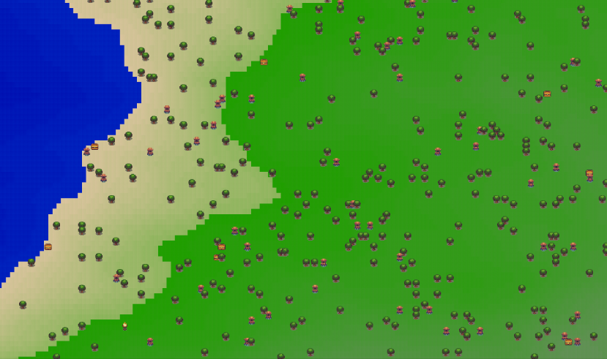Fig. 1 Poor variation in terrain.

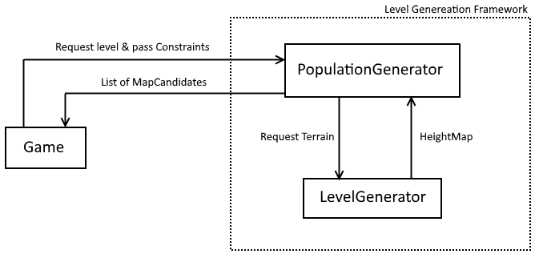Fig.2 Design Overview

Genetic Algorithm – A method to solve optimisation problems by modelling the natural selection process. A population of potential solutions is maintained and every iteration a new generation is created by combining the more successful solutions until the optimal is “evolved”.
Constructive PCG – A loose collective term for PCG methods that perform no evaluation of the content produced. These techniques are designed to execute once and must generate usable content.

